CS-250 Sprint Review and Retrospective

Week 7 Final Project – Date 2/20/2025

Christopher Barnes

Sprint Retrospective and Review

A project requires team effort, no single person can inherently do the job of a team except the team itself. The team that I had the liberty of working with consisted of a Product Owner, Scrum Master (Me), Developer and Tester. Together we worked on this project for SNHU that required all our brains and skills to work together as our client wanted to develop a travel app. Our product owner first met with the clients at SNHU Travel to get an initial project idea of what they were looking for, albeit was not 100% exact and did encounter change later, it was a start and a good one at that. I as the scrum master has the liberty of joining the product owner in that initial meeting to start taking notes on how we would develop the epics and user stories to our developer and tester in preparation for the Scrum Meetings as we felt this project really required utilizing the Agile Method over a Waterfall.

The product owner got to work starting the user stories and backlogging while I met with our team for the daily standups to start laying out sprint timelines that we could all agree and meet. With the team alignment, our developer and tester felt it best due to our stricter timeline to utilize pair programming ensuring that the project would not lose oversight, or progress should A person in a suit
one or the other be out for a day or period during our project.

We started getting stories completed by priority levels and size and the app was coming together until we hit an interruption, the user wanted to change our overall approach to be more specific.

I thought our developer was going to have a mental breakdown given our already restricted deadline. However, the team came together and started to make the shift, as most of the user stories had already built the foundation the changes were easier to make, that’s the beauty of agile over waterfall, it doesn’t set you back much even when changes are real time because you can act in real time also. But it is important to realize that this change did come on its own, the team required communication and that was just as crucial as getting the project done.

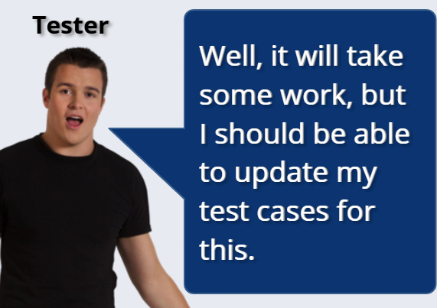 The tester let us know during our sprint sessions that he could update the test cases to make this a bit easier on the group deadline as well. This was effective because the developer and tester were working through pair programming at first, the bulk of the project was complete already, and siloing into their specializations made it easier to focus and come back together for our daily standups.

It was important to note that during our sessions and even outside of our sessions we needed to keep things organized and that is where we agreed that organizational tools like that of Jira boards would be beneficial to tracking the development of our progress. When our developer and tester complete stories they go on the board and mark it complete, actively completing their daily, and weekly goals. By utilizing these organizational tools, it allowed myself and more importantly the product owner to show progress to the clients and help organize our backlog should anymore changes take place.

The team accomplished it but like all teams they had their own hurdles and challenges to work through and as I look back even in my role of Scrum Master, the sudden shifts that made this project harder also brought our team closer. We were able to work closer together because the project required us to have agility and nimbleness to manage any unforeseen changes like that of shifting the focus of the project from overall destinations to wellness/detox, and I couldn’t think of no better method other than an agile environment to complete this project in. To me and my team, there were no cons that would have affected this project by being agile, only if it were not doing as an agile environment would there have been a con.

In the end, by using agile methodology, Jira boards for organizing our backlog and user stories, pair programming and silo-ing along with doing our daily standups and sprints, it really put our team in focus and accountable by asking ourselves those three main questions every morning. “What did we accomplish yesterday” – “What will we accomplish today” – “What hinders us.” Turns out the client was incredibly happy with our project and meeting our deadline by a week early, and heard rumors there may be another app getting ready to develop for them due to our magnificent work and guess who is agile enough to manage it – “This Team.”